Technical requirements (TR) for development of user interface of «Dialer» program

The following TR will be applied to every following order of mobile devices for data transmission.

- Buttons and their functions:
In dashboard interface of «Dialer», besides facilities to choose the profile for dialing, two buttons should be and each of them should have three modes. The title on the buttons should be in three languages - Ukrainian, Russian and English. The buttons are given for familiarization because they belong to the other similar SW of the other producer.
1.1.1
The first Normal mode:
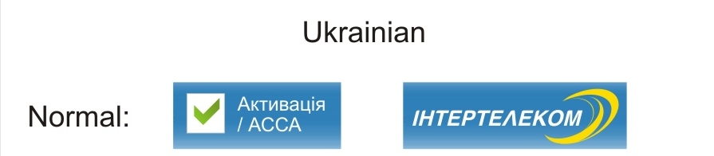

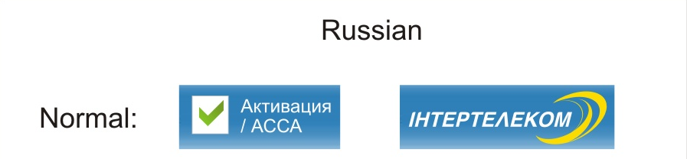

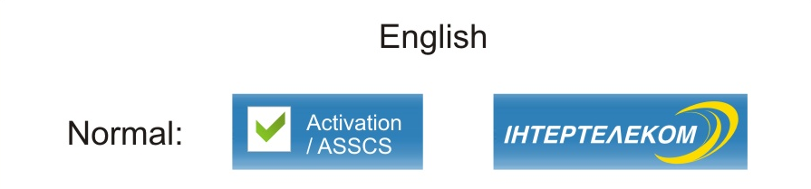

1.1.2
The second Selected mode: When you mouse over the area of the buttons, prompting messages in appropriate languages should appear as it is shown below.

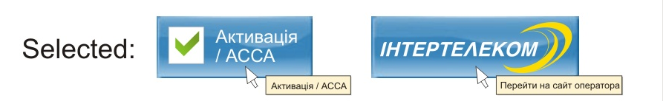

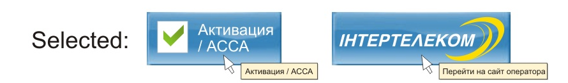

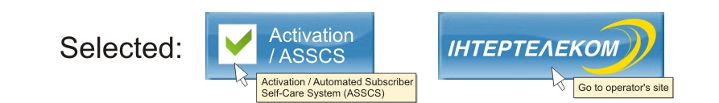

1.1.3
The third Pushed/Active mode: For the button «Activation/АССА» pushed state should stay till the subscriber pushes the button again for termination of the session. For the button-link «Интертелеком» pushed state should remain only for the moment when you push on it.
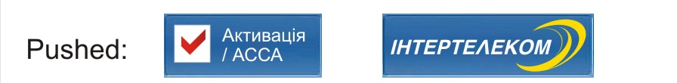

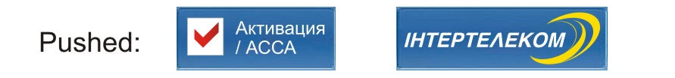

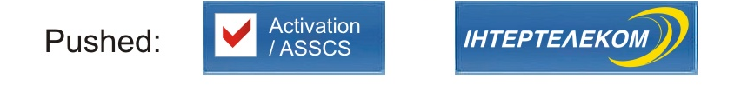

1.1.4
Logic and sense function of the button «Activation/АССА» is a pre-installed profile with the parameters:
Name of the profile Rus/Ukr/Eng: «Активация/АССА»/ «Активація /АССА»/ «Activation/ASSCS
Login: IT_TEST
Password: IT_TEST
Dialing number: #777
Authorization type: PAP/CHAP

1.1.5
While using the profile «Activation/АССА» other profiles should be inaccessible. In case of a successful dealing session of «Activation/АССА», a dialed call of the WEB-browser window should occur, it was set by default with detailed address for redirection to the page: assa.intertelecom.ua for ОС Windows and
http://assa.intertelecom.ua, for MAC OS.
You should pay attention to the fact that the address for ОС Windows must be the following - assa.intertelecom.ua, without http or www.

1.1.6
Logic and sense function of the button-link «Интертелеком» is redirection to the site of the company (www.intertelecom.ua) with help of WEB-browser, set by default.

1.1.7
The example of the similar SW:

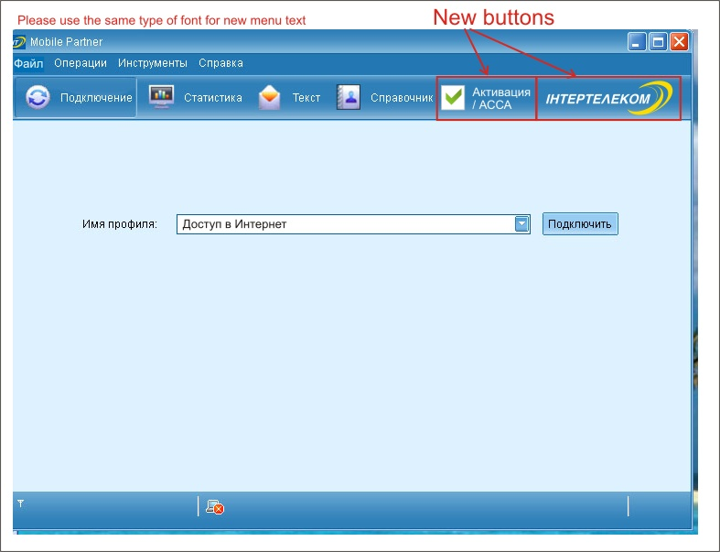

2. Profiles:
2.1
Three pre-installed profiles should be created: «Activation/АССА», «Access to Internet» and «TURBOAccess to Internet»
2.1.1 The profile «Activation/АССА» was described before.
2.1.2 The profile «Access to Internet» should have the following parameters:
Name of the profile Rus/Ukr/Eng: « Доступ в Интернет»/ «Доступ до Інтернету»/ «Access to Internet»
Login: IT
Password: IT
Dialing number: #777
Authorization type: PAP/CHAP
.

2.1.3
The profile «TURBOAccess to Internet» should have the following parameters:

Name of the profile Rus/Ukr/Eng: «ТУРБОДоступ в Интернет»/ «ТУРБОДоступ до Інтернету»/ «TURBOAccess to Internet»
Login: 3G_TURBO
Password: 3G_TURBO
Dialing number: #777
Authorization type: PAP/CHAP
This profile should be installed by default.

3. Initial set-up of EvDO modems and SW «Dialer»:

3.1 While initial connection of the modem to USB-port of the computer, the window with prompt to install the program «Dialer» appears.
3.2 While repeated connection of the modem to USB-port, auto-start of «Dialer», that is ready for use, should occur after successful set-up of the program «Dialer».
3.3 In case of unsuccessful set-up of SW «Dialer» item 3.1. will be repeated while every following connection of the modem to USB-port.

4. Description of the remaining functions of «Dialer»:
Minimum of facilities is required from SW«Dialer» at this stage.
You should exclude all additional content (Music, Video, Games…)

